School Strategic Plan for
Wodonga West Primary School
4814
2016 -2019

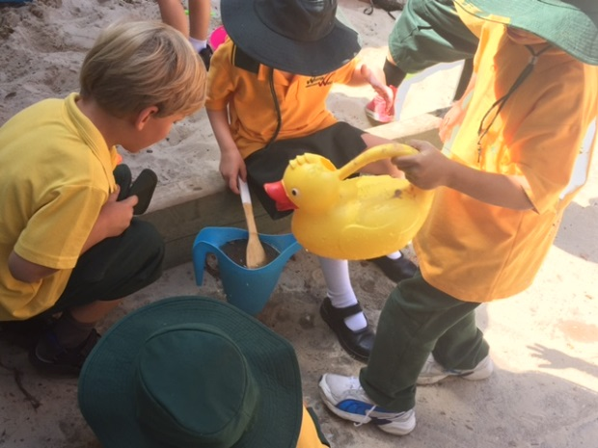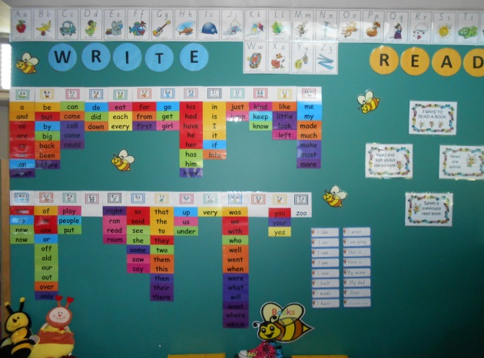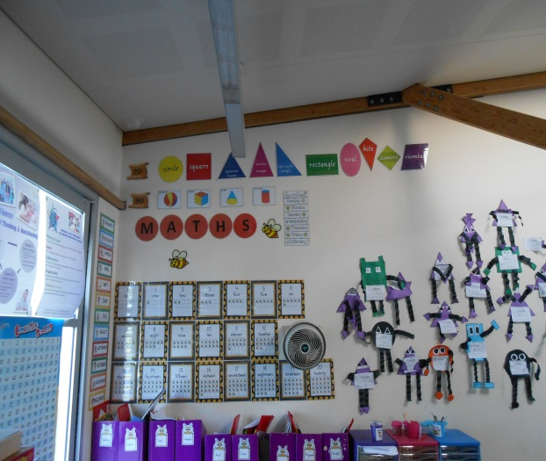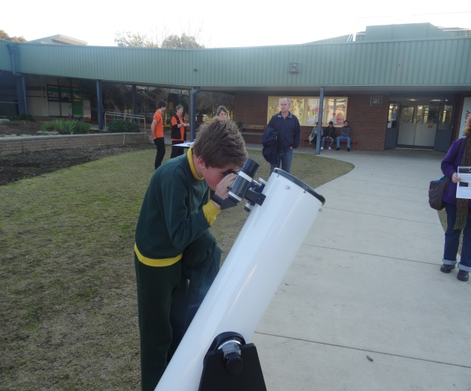

Endorsements
Endorsement by School Principal | Signed……………………………………….  Name Jocelyn Owen  Date……………………………………………
Endorsement by School Council | Signed……………………………………….  Name Shelley Jolliffe  Date……………………………………………  School Council President’s endorsement represents endorsement of School Strategic Plan by School Council
Endorsement by the delegate of the Secretary | Signed……………………………………….  Name………………………………………….  Date……………………………………………

School Profile
Purpose
The concept of a vision for a school has been demonstrated to be an essential characteristic in the school improvement and effectiveness research over several decades and across a wide range of education systems. Such a statement provides a foundation for the school’s strategic planning decisions and for ongoing performance against the school’s stated objectives and values.

Regulatory context
In order to be registered, all Victorian schools must meet a set of minimum standards, which are regulated by the Victorian Registration and Qualifications Authority (VRQA). Under the VRQA’s School Governance standard, “a school must have a clear statement of its philosophy”. The statement is expected to cover the school’s vision, values, mission or objectives, including an explanation of how the school’s philosophy is enacted and articulated to staff, students, parents, guardians and the school community.

Purpose

Our School has a shared vision ‘ Learning for Living’ which underpins our whole school philosophy and purpose for existing as a State Government school. This vision encapsulates the whole child as learner at the centre. It reflects the types of learning experiences we strive to provide, as well as the expectations and skills we build towards growing lifelong learners able to think and critically reflect on an ever-changing world. At Wodonga West Primary School we are cognizant of the fact that we are nurturing the minds and bodies of our students in all facets of academics ( especially literacy and numeracy ) as well as physical and emotional development.
Values
Our school encourages healthy home – school partnerships with our parent community.
The school has a strong commitment to the School Wide Positive Behaviour Support program . This has involved whole community consensus to arrive at our school behaviour expectations and values of Be Safe, Be Respectful, and Be a Learner. With the coaching ending part way through our training, we are keen to continue this with the implementation of Koorie Inclusive School Wide Positive Behaviour Support ( KISWPBS ).

Environmental Context
Wodonga West Primary School is over 55 years old and is sited on the fringe of the Central Business District of Wodonga. It has a proud history of innovation in education and technology and developing staff with leadership capacity as well as mentoring and developing new graduates. The school population is traditionally from the low socio economic group with several Defence families and growing numbers of students with Language Backgrounds Other Than English ( LBOTE ) and Aboriginal and Torres Strait Island ( ATSIC ) populations. There is a core of very experienced teachers who have been at Wodonga West Primary School for a long period of time with new graduates also part of the staffing profile.
Under the Building the Education Revolution ( BER) program in 2011 we were able to occupy a flexible (non-template) learning space and Resource Centre built as the first part of our overall redevelopment plan. Our Junior school moved into this space to utilise the new pedagogies available. We were excited to receive $3.8million in the 2014 budget to complete the rebuild of our older Buildings which will be completed during 2016 in readiness for the 2017 school year. In addition we were successful in obtaining a Children’s Capital Grant of $650,000 to develop an Integrated Early Learning Centre on site with Allied Health spaces .This opens up opportunities for developing and establishing partnerships with service providers ( such as Maternal and Child Health ) to create a ‘one stop shop’ for our community as well as exciting possibilities around the curriculum from Pre School to year 6.
Wodonga West has been experiencing declining enrolments. (From 398 in 2011 to a projected 170 in 2016). This is something we are keen to address as we would consider an enrolment of at least 300 as ideal.
Development and commitment to a number of additional programs which embraced our school vision of “Learning for Living” have been implemented that encompass a holistic approach to education . This includes a Stephanie Alexander Kitchen Garden, aspirational programs such as ‘Studio West’ and ‘Training for Trades’ for Middle Years of Schooling students, AVID (Advancement Via Individual Determination ) , Bluearth (a holistic and physical wellbeing program F-6), links with Charles Sturt University through the ‘Future Moves’ Program and Compass Awards have all added to the breadth of our curriculum and offered a point of difference to other neighbouring schools.
Our SFO has increased to 0.74 and there has been an increase in Koorie students (11% of our school population) and Language Background Other Than English ( 11% -many from refugee backgrounds). Significantly our cohorts in Foundation (and through the school) have become increasingly challenging in terms of their entry literacy and numeracy levels and the complexity of their families.
The school has a Primary Well-Being Officer and in the past twelve months has funded an Attendance Officer and we also have a Koorie Education Support Officer, a designated English as Additional Language Teacher and a Multi- Cultural aide, a Defence Transition Aid and Kitchen and Garden Specialists for the ‘Stephanie Alexander Kitchen Garden’ Program. We recognise that healthy development and education is a shared responsibility, with families and the wider community, learners, and our services all playing a role. Health and wellbeing is an important outcome in its own right, but it is also a precondition for learning and employment, and is an indicator of successful education.
To support our families, we also offer a friendly ‘Out of School Hours’ Childcare program on site.

Service Standards
(optional)
General
- The school fosters close links with parents and the broader school community through its commitment to open and regular communications.
- The school commits to the active sharing of its vision’ Learning for Living’ and goals to ensure school community engagement in the school’s strategic plan.
- The school guarantees all students access to a broad, balanced and flexible curriculum including skills for learning and life.
- The school provides a safe and stimulating learning environment to ensure all students can achieve their full potential.
- All students will receive instruction that is adapted to their individual needs.
Specific
- The school will respond to all communication by parents and caregivers within a timely manner.
- Parents will be engaged regularly when their child does not behave in a socially acceptable manner.
- Students will play an active part in the development and review of the school’s behaviour policies.
- All teachers will provide timely and targeted feedback to students on their work.

- The school offers specialist classes in Science, Physical Education, Visual and Performing Arts and Indonesian as well as a Stephanie Alexander Kitchen Garden Program with trained Kitchen and Garden specialists

- Advancement Via Individual Determination ( AVID ) is a school wide priority utilizing a system of strategies for success

- Staff are trained in and implement Bluearth, a holistic approach to physical and emotional wellbeing

- The school adopts the ‘Team Around the Learner’ approach to support the emotional wellbeing of students

Strategic Direction
Purpose: A school’s strategic direction is defined by goals and targets for improvement in the four outcome areas, and key improvement strategies to achieve the goals and targets.
Schools have significant flexibility in defining their goals, targets and key improvement strategies according to the needs and expectations of their community. Typically, the Strategic Plan will have one goal against each outcome area, though schools may choose to include more.

The goals, targets and key improvement strategies articulated in the School Strategic Plan will underpin individual performance and development planning for school staff.

Regulatory context
Under the Education Training and Reform Act 2006 Section 2.3.24, subsection (1) of the Act states that:
“A school council must, in accordance with any Ministerial Order, prepare a school plan that sets out the school's goals and targets for the next 4 years and the strategies for achieving those goals and targets.”

Achievement  Achievement refers to both the absolute levels of learning attainment and growth in student learning that schools strive to support.  While recognising that literacy and numeracy are essential foundations for students’ success, achievement outcomes encompass a broader view of learning, spanning the full range of curriculum domains, as well as students’ co-curricular achievements. |  | Key improvement strategies  Key improvement strategies are the high-level actions that the school will undertake to achieve its goals and targets. They represent the sequential process of change that will need to occur if the goals and targets are to be realised. Key improvement strategies are broad and are likely to take several years to implement successfully and sustainably. Implementation of the key improvement strategies will be documented in detail through the school’s Annual Implementation Planning process.
Goals  Goals are aspirational statements. They define what outcomes the school is striving to achieve. Goals evolve from the school’s purpose, values and context and build on the analysis of student outcomes undertaken through the self-evaluation and review processes. | To maximise student learning in the core subject areas of Literacy and Numeracy. | IMPROVEMENT FOCUS ONE:  To improve English Achievement level F-6 with a particular focus on Writing  To develop and implement an annual Literacy Action Plan to achieve high quality educational outcomes for all students in Literacy  …………………………………………………………………………………  IMPROVEMENT FOCUS TWO:  To improve student achievement in individual growth levels in Mathematics F-6  To develop and implement an annual Numeracy Action Plan to achieve high quality educational outcomes for all students in numeracy
Targets  Targets are defined measures of the successful achievement of the school’s goals. Targets can take a number of forms and may focus on the outcomes achieved by all students, such as the learning growth all students will be expected to achieve, or on the outcomes of a smaller group of students. | In Literacy and Numeracy, every student deemed capable is to achieve at least 1 year’s learning growth annually against Victorian Curriculum Standards.  In NAPLAN for Literacy and Numeracy, decrease the number of students in the low gain domain.
Theory of action (optional)  The Theory of Action explains the rationale behind the key improvement strategies, i.e. how the strategies will achieve the goals articulated in the Plan. | If we are consistent in implementing the Literacy and Numeracy Action Plans then students will have the optimum chance of achieving one year’s learning growth annually.
 | Actions  Actions are the specific activities to be undertaken in each year to progress the key improvement strategies. There may be more than one action for each strategy. Schools will choose to describe actions with different levels of detail. | Success criteria  Success criteria are markers of success. They are useful in demonstrating whether the strategies and actions have been successful. Success criteria often reflect observable changes in practice or behaviour. To simplify and focus the school’s monitoring of progress, only a limited number of success criteria should be set.
Year 1 | - Develop consistency in documentation and rigour of planning in term and weekly planners.  - Build staff capacity in understanding the strands of the Victorian Curriculum in Literacy and Numeracy ( and their relationships to our interview assessment pieces).  - Ensure a school wide consistency in assessment practices, fluency and homework tasks and use of data to drive teaching.  - Maintenance of Words Their Way spelling approach.  - Investigate school-wide Writing program eg. Big Write/VCOP  - Expand and consolidate staff knowledge of the Literacy / Numeracy skills required in NAPLAN testing.  - Professional learning on classroom observations  - Review Literacy and Numeracy Plans at end of year 1 | Documentation completed, stored centrally and shared  Planning documents ( Placemat instructional model ) in place  Classroom Observations reflect placemat model and consistent planning  Moderation and data informing planning  Decision made on whole school writing program  School wide data indicates student progress  Time allocation of PLT’s  Professional learning completed
Year 2 | - Develop actions from the annual Literacy , Numeracy and ICT Plans which support current data , staff development and ensure high expectations and increased differentiation  - Ensure continued staff commitment to instructional model and practice.  - Continued PLTs to build staff capacity to understanding the Mathematical continuum and the ‘sticking points’.  - Continue PLTs to ensure consistent use of data and assessment practices in Literacy and Numeracy.  - Improve differentiation and personalisation to ensure challenge and progress for every student (one year’s growth for one year of school).  - Maintenance of Words Their Way spelling approach.  - Expand and consolidate staff knowledge of the Literacy Skills in NAPLAN and how these can be taught.  - Staff development - Writing program  - ICT professional learning is linked to building staff confidence and capability in the use of ICT to improve teaching and learning  - Review Literacy and Numeracy Plans at end of year | Planning documents and classroom observations ( Placemat instructional model ) in use  Classroom Observations with a focus on : Instructional Model, Writing approach and numeracy sticking points  Regularly scheduled Numeracy and Literacy PLT’s  Evidenced in program planning and classroom instruction  Staff will be trained in agreed Writing Approach
Year 3 | - Develop actions from the annual Literacy and Numeracy Plans which support current data , staff development and ensure high expectations and increased differentiation  - Maintenance of Words Their Way spelling approach.  - Staff development - Writing program  - Review Literacy and Numeracy Plans at end of year | Staff will be trained in agreed Writing Approach
Year 4 | - Develop actions from the annual Literacy and Numeracy Plans which support current data , staff development and ensure high expectations and increased differentiation  - Maintenance of Words Their Way spelling approach.  - Staff development - Writing program  - Review Literacy and Numeracy Plans at end of year | Staff will be trained in agreed Writing Approach

Engagement  Engagement refers to the extent to which students feel connected to and engaged in their learning and with the broader school community.  Engagement spans students’ motivation to learn, as well as their active involvement in learning.  Engagement also refers to students engagement as they make critical transitions through school and beyond into further education and work. |  | Key improvement strategies  Key improvement strategies are the high-level actions that the school will undertake to achieve its goals and targets. They represent the sequential process of change that will need to occur if the goals and targets are to be realised. Key improvement strategies are broad and are likely to take several years to implement successfully and sustainably. Implementation of the key improvement strategies will be documented in detail through the school’s Annual Implementation Planning process.
Goals  Goals are aspirational statements. They define what outcomes the school is striving to achieve. Goals evolve from the school’s purpose, values and context and build on the analysis of student outcomes undertaken through the self-evaluation and review processes. | Build positive school and community relations with high expectations and an orderly learning environment. | IMPROVEMENT FOCUS:  Develop relationships with key stakeholders to build the best opportunities for 0 – 5 year olds  To refine and embed the WWPS instructional model linked to staff Performance and Development Plans and whole school teacher PD plan  Introduce Science as a Specialist subject area to engage, inspire and equip students to pursue possible Science career paths ( in line with STEM )
Targets  Targets are defined measures of the successful achievement of the school’s goals. Targets can take a number of forms and may focus on the outcomes achieved by all students, such as the learning growth all students will be expected to achieve, or on the outcomes of a smaller group of students. | Attitude to school survey data in the area of Student Engagement reaches the 40th percentile and improves annually  Staff opinion data to improve annually to reach the state wide mean
Theory of action (optional)  The Theory of Action explains the rationale behind the key improvement strategies, i.e. how the strategies will achieve the goals articulated in the Plan. | If we provide improved opportunities for Student Voice and community links with learning; motivation, connectedness and engagement  should improve.
 | Actions | Success criteria
Year 1 | - Continue to embed AVID and programs with CSU  - Staff complete the ePotential survey to inform staff development / training  - Review and refine the WWPS instructional model linked to staff Performance and Development Plans and whole school teacher P.D. plan ( including Educator Impact )  - Ensure staff commitment to a common school wide research based instructional model.  - Develop and implement a community links plan to be linked to this process and ‘futures search’  - Investigate and plan for implementation of student led conferences ( template designed to guide staff / students )  ……………………………………………………………………………………..  - To develop a whole school Science scope and sequence plan that complements our whole school Curriculum Plan - Rich Tasks based on Victorian Curriculum  - Allocate finances towards Science resources and materials  …………………………………………………………………………………………..  - 0-5 year old Operations and Governance action plan devised for ELC | AVID strategies for success are evident in all classrooms  A strong partnership with Charles Sturt University is established and apparent including Future Moves Program  Develop a whole school 4 year action plan for improving aspirations for students and families  Conversations with students and families include high expectations around future success, school completion and employment aspirations  School has a community link plan which it is enacting  School has a 4 year plan for raising aspirations within the school and community  ePotential survey completed with data used for decision making  Science Scope and Sequence documentation  Use Survey Monkey to create a survey of students, parents and staff to measure the success of the science program  Operation and Governance Plan developed for ELC
Year 2 | - Develop a climate of high expectations for students, staff and community  - ICT is used to support contemporary skills including higher-order thinking, decision making, communication, collaboration, creativity and problem solving  - Teachers allocate different digital resources to different learners according to need with ICT having a positive impact on students’ engagement  - Students use digital portfolios to store work electronically  - ICT professional learning is linked to building staff confidence and capability in the use of ICT to improve teaching and learning | Opinion data indicates an increasing climate of high expectations  ICT is effectively utilised as a tool for teaching and learning  Professional learning is completed  AVID accreditation is continuing to occur progressively
Year 3 | - Continue to develop a climate of high expectations for students, staff and community  - Refine Student Led Conference process  - Ensure staff commitment to a common school wide research based instructional model. | A common , agreed process is developed to guide student led conferences
Year 4 | - Continue to develop a climate of high expectations for students, staff and community  - Refine Student Led Conference process  - Ensure staff commitment to a common school wide research based instructional model. | A common , agreed process is developed to guide student led conferences

Wellbeing  Students’ health, safety and wellbeing are essential to learning and development. An inclusive, safe, orderly and stimulating environment for learning is critical to achieving and sustaining students’ positive learning experiences. |  | Key improvement strategies  Key improvement strategies are the high-level actions that the school will undertake to achieve its goals and targets. They represent the sequential process of change that will need to occur if the goals and targets are to be realised. Key improvement strategies are broad and are likely to take several years to implement successfully and sustainably. Implementation of the key improvement strategies will be documented in detail through the school’s Annual Implementation Planning process.
Goals  Goals are aspirational statements. They define what outcomes the school is striving to achieve. Goals evolve from the school’s purpose, values and context and build on the analysis of student outcomes undertaken through the self-evaluation and review processes. | Enable a calm, safe and effective learning environment where every student is known well by school staff. | IMPROVEMENT FOCUS:  To maximise student attendance and punctuality  Build an organisational culture that facilitates working collaboratively to promote and support the ‘whole’ person including learning, development, skills, health and wellbeing  Continuous improvement of the shared understanding of behaviour expectations / management as aligned to the SWPBS model  Develop and embed a whole school student management system including SWPBS and high expectations
Targets  Targets are defined measures of the successful achievement of the school’s goals. Targets can take a number of forms and may focus on the outcomes achieved by all students, such as the learning growth all students will be expected to achieve, or on the outcomes of a smaller group of students. | An improvement to be equal or above State Mean in Departmental Surveys and in the school community perception of student safety as evidenced through focus groups.
Theory of action (optional)  The Theory of Action explains the rationale behind the key improvement strategies, i.e. how the strategies will achieve the goals articulated in the Plan. | If we establish one of the preconditions for improved student learning (establishment of a safe and orderly learning environment), then our staff will be able to focus fully on teaching, and students on learning.
 | Actions | Success criteria
Year 1 | - Implement year 1 of KISWPBS plan  - Continue implementation of ‘Lateness Strategy’  - Implement Team Around the Learner to support a wrap - around approach to student wellbeing  - Provide Bluearth P.D. for staff  - Access the KISWPBS training for SWPBS team to enable SWPBS Team to be fully trained  - Build partnerships with families, health and wellbeing services and other relevant community services who are seen as partners in the creation of healthy environments and good health and wellbeing  - Re-visit the ‘Positive Relationships’ module of Classroom Teaching Techniques ( CTT ) | SWPBS training has been re-initiated for team  Data collection indicates a reduction in numbers of students who are arriving late for school  New families to the school at Foundation level complete a ‘Team Around the Learner’ proforma to identify key supports and ways we can best transition students  Time has been allocated in meeting schedule to ‘Positive Relationships’ CTT at beginning of the year
Year 2 | - Implement year 2 of KISWPBS Plan  - Integrate service delivery to families in new Early Learning Centre facility including  MCH  - Build partnerships with families, health and wellbeing services and other relevant community services who are seen as partners in the creation of healthy environments and good health and wellbeing  - For Bluearth to remain an available program in our school  - Refine and embed Team Around the Learner to support a wrap- around approach to student wellbeing | SWPBS team has had opportunity to complete their training  Families are increasingly accessing the integrated Allied Health services from the Early Learning Centre over time  Bluearth program is in action and a common language developed  TAL is operating within the school
Year 3 | - Implement year 3 of KISWPBS Plan  - Build partnerships with families, health and wellbeing services and other relevant community services who are seen as partners in the creation of healthy environments and good health and wellbeing  - Build leadership capacity to effectively promote and support health and wellbeing  - Integrate service delivery to families in new Early Learning Centre facility including  MCH  - Consolidate service delivery for families in the new ELC | Families are increasingly accessing the integrated Allied Health services from the Early Learning Centre over time  Additional Allied Health service providers are on site
Year 4 | - Build partnerships with families, health and wellbeing services and other relevant community services who are seen as partners in the creation of healthy environments and good health and wellbeing  - Build leadership capacity to effectively promote and support health and wellbeing  - Integrate service delivery to families in new Early Learning Centre facility including  MCH | Families are increasingly accessing the integrated Allied Health services from the Early Learning Centre over time  Additional Allied Health service providers are on site

Productivity  Productivity refers to the effective allocation and use of resources, supported by evidence and adapted to the unique contexts of each school.  Successful productivity outcomes exist when a school uses its resources – people, time, space, funding, facilities, community expertise, professional learning, class structures, timetables, individual learning plans and facilities – to the best possible effect and in the best possible combination to support improved student outcomes and achieve its goals and targets. |  | Key improvement strategies  Key improvement strategies are the high-level actions that the school will undertake to achieve its goals and targets. They represent the sequential process of change that will need to occur if the goals and targets are to be realised. Key improvement strategies are broad and are likely to take several years to implement successfully and sustainably. Implementation of the key improvement strategies will be documented in detail through the school’s Annual Implementation Planning process.
Goals  Goals are aspirational statements. They define what outcomes the school is striving to achieve. Goals evolve from the school’s purpose, values and context and build on the analysis of student outcomes undertaken through the self-evaluation and review processes. | Ensure strong and effective leadership is shared, stable and sustained over time, and includes operation of the Early Learning Centre in order to improve student achievement, engagement and wellbeing. | IMPROVEMENT FOCUS ONE:  Develop and implement a Leadership capacity building plan  IMPROVEMENT FOCUS TWO:  Develop an Implementation Plan for the Early Learning Centre including timelines etc. ( Gantt chart )  All the school’s plans are aligned from the Strategic Plan , AIP, and Principal, Teacher and ES P&D Plans  School Leadership Team has improved role clarity through links from the Strategic Plan down to their annual P& D plans
Targets  Targets are defined measures of the successful achievement of the school’s goals. Targets can take a number of forms and may focus on the outcomes achieved by all students, such as the learning growth all students will be expected to achieve, or on the outcomes of a smaller group of students. | To provide an integrated Pre School service on site in 2017 which has access to other service providers  To build the capacity of the middle level leaders – Literacy and Numeracy Leaders, to drive improved student learning outcomes  Staff Opinion Survey to be at or above the state mean in the areas of ‘collective efficacy’’ and ‘shielding & buffering’
Theory of action (optional)  The Theory of Action explains the rationale behind the key improvement strategies, i.e. how the strategies will achieve the goals articulated in the Plan. | If we foster and develop shared leadership, the school and Early Learning Centre will be in a strong position to support families from 0- 12 years of age.  Leadership capacity building is essential to the successful implementation of the Strategic Plan.
 | Actions | Success criteria
Year 1 | - Identify staff who will be pivotal in working as mentors with less experienced staff or staff who identify specific areas for improvement  - Engage with external Dept. staff re Early Learning Centre – Jo Bruce and Robyn Bourke re operations, philosophy, curriculum and governance  - Build community partnerships to support the 0-12 age group including Linking Learning project  - The school will develop a philosophy that will underpin the operations of the ELC  - Invest in staff Professional Development to build leadership capacity  - Staff P & D Plans are aligned to the school AIP | Staff has identified their desire to seek leadership roles and have identified a possible career pathway through individual P & D Plans.  Operational and financial viability plans are completed and enacted for 2017 opening of ELC.  Early Learning Centre is operational for the 2017 school year and Allied Health partnerships are enacted.  Enrolments are at optimal levels for operating ELC.  Staff Performance and Development Plans have been developed , implemented and reviewed twice per year  Key staff have completed leadership capacity building P.D.
Year 2 | - Invest in staff Professional Development to build leadership capacity  - Review operations and direction of Early Learning Centre and plan outcomes for year 3 and 4  - Staff P & D Plans are aligned to the school AIP | Key staff have completed leadership capacity building P.D.  Early Learning Centre is operational and viable
Year 3 | - To be reviewed after analysis of the year 2016 and 2017 Annual Implementation Plans  - Staff P & D Plans are aligned to the school AIP
Year 4 | - To be reviewed after analysis of the year 2017 and 2018 Annual Implementation Plans  - Staff P & D Plans are aligned to the school AIP

